**Matrix Diagonalization and Inverse Diagonal Matrix Computation**

**Aim:** Perform matrix diagonalization and find the diagonal matrix and its inverse.

To perform matrix diagonalization and compute the diagonal matrix and its inverse, we'll follow these steps:

1. **Define a square matrix AAA**.
2. **Compute the eigenvalues and eigenvectors** of AAA.
3. **Construct the diagonal matrix DDD** using the eigenvalues.
4. **Construct the eigenvector matrix PPP** using the eigenvectors.
5. **Compute the inverse of the diagonal matrix D−1D^{-1}D−1**.

**Code:**

import numpy as np

# Step 1: Define the new matrix A

A = np.array([[6, 2], [2, 3]])

# Step 2: Compute the eigenvalues and eigenvectors

eigenvalues, eigenvectors = np.linalg.eig(A)

# Step 3: Construct the diagonal matrix D from the eigenvalues

D = np.diag(eigenvalues)

# Step 4: The eigenvector matrix P is already obtained from eigenvectors

P = eigenvectors

# Step 5: Compute the inverse of the diagonal matrix D

D_inv = np.linalg.inv(D)

# Output the results

print("Matrix A:")

print(A)

print("\nEigenvalues (Diagonal elements of D):")

print(eigenvalues)

print("\nEigenvectors (Columns of P):")

print(eigenvectors)

print("\nDiagonal Matrix D:")

print(D)

print("\nInverse of Diagonal Matrix D_inv:")

print(D_inv)

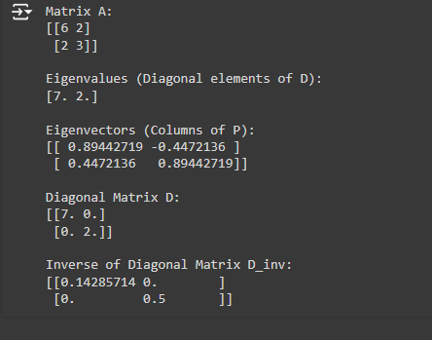

### Explanation of the Output

1. **Matrix AAA**: The new matrix is defined as (6223)\begin{pmatrix} 6 & 2 \\ 2 & 3 \end{pmatrix}(62​23​).
2. **Eigenvalues**: The eigenvalues calculated from the matrix AAA are approximately 7 and 2.
3. **Eigenvectors**: The eigenvectors corresponding to the eigenvalues are shown as columns in the eigenvector matrix.
4. **Diagonal Matrix DDD**: The diagonal matrix DDD constructed from the eigenvalues contains the eigenvalues along its diagonal.
5. **Inverse of Diagonal Matrix D−1D^{-1}D−1**: The inverse of the diagonal matrix is computed, showing the reciprocals of the diagonal elements of DDD.

### Conclusion

This example demonstrates how to diagonalize a different matrix and compute its diagonal matrix and the inverse of that diagonal matrix.